The development of the Piano

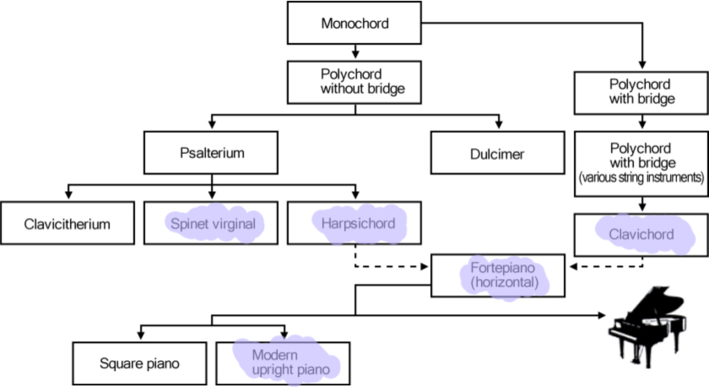

The history of the piano keyboard comes from the first hammered piano-like instrument(s) such as dulcimers, used since the middle ages in Europe. During that time, there were many attempts to create a keyboard instrument with hammered strings.

Several years passed, and during the 17th-century, instruments such as the clavichord and the harpsichord were developed. Both the clavi and the harpsi used plucking instead of striking, i.e., the clavichord used a brass tangent, and the harpsichord used quills, both activated when pressing the keys.

After putting centuries of work into the piano background mechanism of the harpsichord, builders were shown the most effective way to construct everything from the case to the soundboard, bridge, and mechanical actions needed to sound the strings.

The first keyboard instrument to be used in music was the organ (the ones found in churches). The future inventors used the technological advances of that instrument to further their knowledge into what would become the modern piano.

The piano music definition: Piano, in theoretical terms, means to play quietly, and this is the reason that Cristofori named it the “pianoforte” because it could play very softly and quietly and loudly as well, and when the modern age came, it was renamed as the piano. This term is used in both instrumental piano music and in orchestral, jazz, and rock music.

The first piano and the history of the piano are attributed to Bartolomeo Cristofori di Padua, Italia. Ferdinando de Medici employed him as keeper of the Instruments.

Being a master builder of the harpsichord and acquainted with the knowledge of stringed keyboard instruments helped him develop the first piano ever made called the Cristofori pianoforte.

Thus, the pianoforte history had its birthplace in Italy. Before inventing the oldest piano, Cristofori had already designed and built two keyboard instruments like the later Cristofori pianoforte.

The inventor of the piano designed it with a harpsichord-style body, but with hammers that had to strike the string, but also had to not remain in contact as it would dampen the sound.

Thus, the earliest piano hammers had to retract to their original starting position without bouncing around in the body.

His mechanism, which helped in the development of the piano, is still used and has been used for centuries in the history of keyboard instruments, but they have also been upgraded through the ages.

The appearance of new materials such as plastics and felt made the instruments last even longer, and thus the first-ever piano doesn’t resemble modern pianos so much now.

# Early Fortepiano

Many of the next generations of piano builders started from the template from Maffei’s article. Gottfried Silbermann, known organ maker, made virtually identical copies of Cristofori’s design of the first piano made. Still, he also included the predecessor invention of the piano sustain pedal, which lifted all the dampening off of the strings simultaneously, which allowed the piano player to sustain the notes even after their fingers had come off the keys.

One of the most known baroque composers, J.S. Bach, was presented as one of Silbermann’s early instruments but disliked it at first as the higher notes were too soft to allow a full dynamic range.

This criticism helped Silbermann devise a better instrument, and Bach became one of his selling agents, saying “Instrument: piano et forte genandt” (which translates to Instrument: plays soft and loud).

During the late 18th century, piano-making had flourished in the Viennese School (Beethoven, Haydn, and Mozart).

These early pianos were built with wooden frames, had two strings per note, and the hammers were covered in leather, and the keys were in negative to the modern grand piano ( meaning the black keys were the natural notes and the white keys were the accidentals). The piano’s full name, or the real piano name, is clavicembalo col piano e forte, which was later shortened.

# Modern Piano

In the 70-year history of piano, between 1790 and 1860, the classical period piano of the Mozart-era underwent many changes that upgraded the instrument.

Composers and pianists wanted to have a deeper, more powerful and sustained sound for their pianos. This was the Industrial Revolution response, which made possible the acquirement of high-quality piano wires for strings, precision casting for iron frames, etc.

Over time, the piano had grown up from the 5-octave range of the 18th century to the 7-octave and beyond tonal range.

During the 1700s, many technological advances were being made in the musical instrument area. Many of those advances are owed to modern piano creator John Broadwood, Robert Stoddart, and Americus Backers which designed a piano in the harpsichord case (the origin of the Grand Piano).

Quickly gaining reputation, Broadwood sent pianos that were larger, louder, and more robust to Joseph Haydn and Ludwig van Beethoven.

These pianos were the first with a range higher than five octaves (5 and 1/5 -the 1790s, 6 octaves – 1810, seven octaves – 1820).

Viennese makers followed these trends but had slightly different piano actions (i.e., Broadwood = robust action / Viennese = more sensitive)

## Parts of the Piano

This part from the history of pianos will present all the different components which make up the piano story with over 12000 individual parts, supporting six functional features: keyboard, hammers, dampeners, bridge, soundboard, and strings.

### Keyboard

Originally, the piano’s keyboard was similar to the one on the harpsichord, with black ebony keys being the natural notes and the white keys made out of ivory or wood covered in a strip of ivory.

### Hammers

Made out of wood and covered in leather (early pianos) or in dense wool felt. They are voiced in order to compensate for the gradual hardening of the felt and the other parts such as the bridge and soundboard and strings may need maintenance.

### Dampeners

These keep the strings from ringing out too much, but back in the 1700s, a known organ maker created the predecessor to the modern to the sustain pedal, releasing these dampeners in perfect sync to let the strings ring out in a “controlled” environment.

### Soundboard

The part of the piano which enables it to produce the vibrant sounds and the signature sound. It can be ornate or simple. This is the base on which the frame inside the piano sits.

### Strings

Depending on the length of these strings, the piano may have a more vibrant and loud sound. For example, there are longer strings in grand pianos that have a larger and richer sound and more inharmonicity of strings.

# The Evolution of the Piano

Throughout the history of the piano, there have been upgrades upon upgrades in the instrument’s quality. Starting from the first hammered instrument, the dulcimer, which originated in ancient Persia, now Iran, many have strived to create a hammered string instrument during the Dark Ages.

By the 1600s, clavichords and harpsichords were well developed. Clavichords use brass tangents, and harpsichords use quills that pluck the string when the player pressed a string.

Using the harpsichord mechanism and the style of the soundboard, the pianoforte inventor Bartolomeo Cristofori managed to create the first hammered piano-type instrument.

He also devised that the hammer must return to its original position and that it must not bounce around inside the body. Using thin strings, this first piano was much quieter than its modern counterpart but much louder, and it sustained the sound more than the clavichord.

The piano offers the best of both worlds when it comes to both the clavichord and the harpsichord. It allows for dynamic control over the volume of the notes played, playing both piano and forte, and performing sharp accents.

## Dulcimer

The dulcimer is an ancestor of the piano, which originated in Iran.  Using hammers to strike the strings demonstrates the most basic principle of the modern piano. The strings are placed above a flat soundboard in pairs or more rare variants such as the three strings per note or four strings per note and are quite similar to the cimbalom, making this the **earliest “piano”** known.

## Clavichord

Built-in the 13th century, the clavichord gained popularity in the 16th century in the music of Bach. It uses a vertical brass strip called a tangent, which is lifted towards a pair of strings when a key is pressed. It is a quiet instrument, but it allows some dynamics control and vibrato.

## Virginal

The first harpsichord in piano history is the virginal. When pressing a key, a jack holding a quill or leather plectrum rises and plucks the string.

The virginal produces a louder tone than the clavichord, but for this, it sacrifices the variety in dynamics, which was one of the clavichord’s defining characteristics.

## Spinet

Having its roots in Italy, the spinet was upgraded by English builders somewhere around Henry Purcell’s time.

The keypresses also pluck the strings, similar to the virginal, BUT the plectrum’s wing shape permits longer strings, which means that the spinet has increased volume and range (up to 5 octaves).

## Harpsichord

Known from the 15th century, the harpsichord body shape (key in line with strings) reached its peak with the Bach and Handel period.

The body shape of this instrument is the one used for the origins of piano, from the pianoforte to the piano of the romantic era to the modern grand piano, it all came from the Harpsichord.

## Cristofori Pianoforte

The history of the pianoforte starts with Bartolomeo Cristofori building several instruments using the harpsichord body shape but used instead of a plectrum, a series of hammers which hit the strings, instead of plucking them.

With this new instrument, players could control both soft and loud hits and was thus named the “pianoforte”.

## Piano of Beethoven’s Time

Beginning with the 18th century, piano builders started extending the keyboard, which allowed 2 new developments to come into play. One was the escapement action for faster note repetition (~1770) and the dampening and soft  pedals (1783).

Some special pedals were also invented and often added to produce effects such as reverb or echo.

## Upright Piano

Already used for harpsichords since the 16th century, German builders started to apply this to the pianoforte as well, starting with the 18th century.

The matter of the fact is that all that they did was to put vertically the body where the strings rest and put the back legs more upfront.

At the beginning of the 19th century, the first “satisfactory” upright pianos were finally invented

## Square Grand Piano

The **evolution of the piano** to the shape of the clavichord by German builders. By the 1830s, these were the predominant forms of piano.

With larger sound and higher string tensions, these were the preferred keyboard instruments of the 19th century, but were gradually replaced by upright pianos, with a smaller footprint and even larger sound.

## Piano of the Romantic Era

Another step in the origin of piano took place in the Romantic era, where the piano continued to grow in size and in response.

For example, 2 of the most known improvements were made by Sebastien Erard, with the double repetition action and the full cast iron frame, created by Alphaeus Babcock, both of which made the invention of the modern extended keyboard.

## Modern Grand Piano

The Modern Grand Piano comes with 88 keys (52 white keys and 36 black) going from A0 to C8 (a whole 8 octaves). The white keys play the natural notes ( C-B) and the black keys play the accidentals (C#-A#).

Having the best qualities of the early keyboard instruments: cross stringing, the sostenuto pedal, the modern sustain pedal and the una corda or one string, this illustrious instrument delights the listener.